**AWS SQS SERVICE**

🡪CREATE A QUEUE

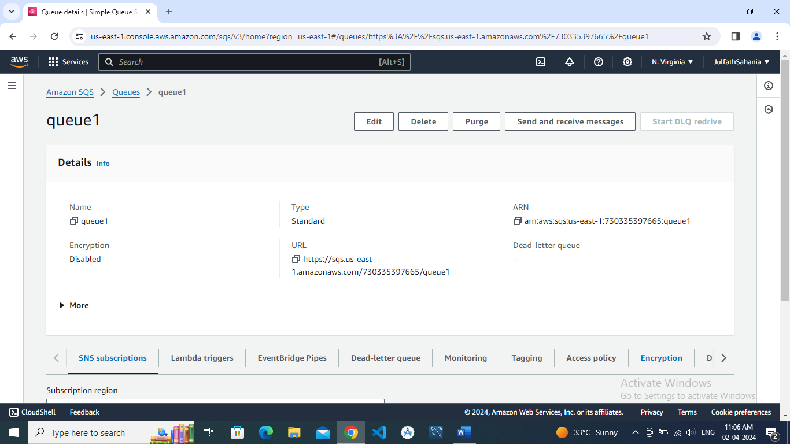

🡪SEND AND RECEIVE MESSAGES

